**Komatsu Forest AB**

**Supplier manual**

**Third edition | 2025**

**FKES 00-000-140**

**FKES 00-000-140**

**Supplier manual**

**First edition | 2019**

**Introduction**

Komatsu Forest AB is committed to meet or exceed our customer’s expectations by providing superior products while displaying excellence in quality, competitiveness, innovation, delivery and service. As an extension of our business operation, we require our suppliers to share in this commitment and drive to 100% On Time Delivery with zero defects.

The Komatsu Forest AB supplier manual provides a general overview of Komatsu Forest AB expectations of its suppliers and practical instructions for their implementation.

This manual is applicable both for existing Komatsu Forest AB suppliers as well as for companies desiring to become a supplier. It is intended to provide guidance how to build supplier operations that meet our company requirements and expectations.

This supplier manual does not overrule any signed agreements, drawings, specifications, and/or instructions applied to specific products in detail.

This manual shall be reviewed and communicated to the appropriate individuals within your organization. Compliance to all requirements listed within this manual is expected.

**and acronyms**

**CNC** = Computer numerical control

CNC is a way of controlling how machine tools operate using a computer.

**COC** = Code of conduct

Code of conduct states business ethics, social and environmental performance criteria for Komatsu Forest AB employees and all business partners.

**FKES** = Forest Komatsu engineering standard

FKES is Komatsu Forest AB standard for internal design processes as well as supplier requirements for manufacturing and transport.

**PDCA** = Plan-do-check-act

PDCA is an iterative, four-stage approach for continually improving processes, products or services.

**PFMEA** = [Process failure mode and effects analysis](http://quality-one.com/pfmea/)

PFMEA is a methodical approach used for identifying risks on process changes. The process FMEA initially identifies process functions, failure modes and their effects on the process.

**PPM** = Parts per million

A measurement of quality performance. To calculate: For example, if you had 25 pieces defective in a shipment of 1,000 pieces. 25/1000= .025 or 2.5% defective. . 025 X 1,000,000 = 25,000 PPM.

**RCA** = Root cause analysis

RCA is a method of problem solving used for identifying the root causes of faults or problems.

**REACH** = Registration, evaluation, authorization and restriction of chemicals

Is a European union regulation. REACH addresses the production and use of chemical substances, and their potential impacts on both human health and the environment.

**SLQDC** = Safety – law – quality – delivery – cost

The "SLQDC" is an acronym for Safety (safety and health), Law (general compliance with the law/compliance with environmental regulations), Quality (quality and reliability), Delivery (timing), and Cost.

**SIM** = Supply integration Manager

A web portal used by Komatsu Forest AB to increase automation of delivery, forecasts, purchase orders, goods label print outs and dispatching.

**EDI** = Electronic data interchange

The computer-to-computer exchange of business documents in standard electronic format between business partners.

**SQA** = Supplier quality assurance

Group within quality assurance department at Komatsu Forest AB. Responsible for part and supplier quality.

**5S** = Sort – set in order – shine – standardize – self-discipline

A methodology that results in a workplace that is clean, uncluttered, safe, and well organized to help reduce waste and optimize productivity.

Contents

1 Safety 1

1.1 Safety and health 1

2 Law 2

2.1 Code of conduct for suppliers 2

2.2 REACH 3

2.3 Komatsu Forest AB approach on reducing CO2 emissions 3

3 Quality 4

3.1 Certification requirements 4

3.2 Commitment to quality 4

3.3 PDCA 4

3.4 Order and cleanliness (5S) 5

3.5 Quality requirements 6

3.6 Monitoring a supplier’s quality performance 7

3.7 Daily management 7

3.8 Personnel 8

3.9 FKES 9

3.10 Quality documents 9

3.11 The supplier’s equipment 11

3.12 The supplier’s own quality controls 11

3.13 Subcontractors 12

3.14 Design review 13

3.15 Supplier changes 13

3.16 Supplier audit 13

3.17 Supplier evaluation 14

3.18 Supplier improvement programmes 14

3.19 Komatsu supplier academy 14

3.20 Supplier risk management plan 14

3.21 Deviation approval request 15

3.22 Change request 15

3.23 Warranty claim handling 16

4 Delivery 18

4.1 Information transfer 18

4.2 Electronic data interchange 18

4.3 Supply integration manager 18

4.4 Dispatching 19

4.5 Managing a dispatch advice in progress 21

4.6 Delivery schedule definition 21

4.7 Delivery accuracy 22

4.8 Packaging 23

4.9 Labelling instructions 24

4.10 Transport instruction 30

4.11 Invoicing 31

5 Cost 32

5.1 Komatsu Forest AB purchasing general conditions 32

5.2 Confidentiality agreement 32

5.3 Request for information, request for quotation 32

5.4 Cost break down 32

5.5 Evaluation of quotation 33

5.6 Supplier evaluation 33

5.7 Audit 33

5.8 Supplier audit (suppliers’ location) 33

5.9 Supplier selection 34

5.10 Supplier implementation 34

1. Safety
   1. Safety and health

Suppliers to Komatsu Forest AB shall ensure that their personnel are not exposed to hazardous operations or work environments that can cause injury in the short or long term.

Suppliers shall systematically conduct work environment management, which includes regular risk analyses, measures, and follow-up, for the purpose of preventing accidents and ill health.

Suppliers shall ensure that personnel have adequate safety and work environment training for the task to be performed and are provided with the necessary safety equipment.

The supplier’s safety culture will be reviewed during supplier audits and visits.

**Up-to-date statistics on incidents and accidents, as well as action taken, shall be provided by the supplier upon request. It should also be possible to demonstrate how the systematic work environment management process is conducted.**

1. Law
   1. Code of conduct for suppliers

The Supplier Code of Conduct sets out what Komatsu Forest AB deems to be ethically correct behaviour in commercial relationships with the companies that supply us with products and services.

Suppliers shall forward the following criteria to their suppliers and subcontractors:

Compliance with laws, regulations, and contracts

The supplier must be aware of and comply with applicable laws, regulations, and contracts. The term ‘regulations’ also includes social responsibility and other internationally established standards for conduct.

Respect for human rights

The supplier must support and respect the protection of internationally recognised human rights and ensure that they are not complicit in human rights violations. Suppliers to Komatsu Forest AB must constantly endeavour to eliminate all forms of forced labour or child labour.

Criminal organisations

Suppliers must not have links with criminal organisations.

Employee rights

The supplier must treat all employees fairly and with respect and dignity. The supplier must provide employees with a safe and healthy work environment. Diversity must be respected, and no employee may be discriminated against or harassed.

Information management/Confidential information

Information of strategic value to Komatsu Forest AB must be treated confidentially and must not be used for any purpose other than cooperation with Komatsu Forest AB.

Gifts

A supplier must not give gifts that may affect the objectivity of employees at Komatsu Forest AB.

Environmental protection

The supplier undertakes to carry out its activities in an environmentally conscious manner. The supplier shall in all respects carry out its activities in accordance with the environmental laws and regulations applicable in the country (countries) in which the supplier operates.

Commitment from the management

The supplier must have a management system in place to ensure compliance with the Supplier Code of Conduct.

* 1. REACH

Suppliers to Komatsu Forest AB shall fulfill REACH regulation (EG) nr 1907/2006. To comply with the regulation, companies must identify and manage risks linked to the substances they manufacture and market. For substances listed on the Candidate list which are manufactured or imported in quantities of 1 ton or more per year per company, manufacturers and importers need to demonstrate that they have appropriately identified and managed the associated risks by means of a registration dossier, which must be submitted to the European Chemicals Agency (ECHA).

* 1. Komatsu Forest AB approach on reducing CO2 emissions

In addition to reducing our own emissions, as a green procurement initiative Komatsu Forest AB will also request our suppliers to act toward reducing their own CO2 emissions. Through efforts such as these, Komatsu Forest AB strives to contribute to a carbon-free future society. Suppliers that have a continuously program for reducing CO2 emissions will, in our regular supplier evaluation, be rated higher than suppliers without such programs.

1. Quality
   1. Certification requirements

Suppliers to Komatsu Forest AB shall, as a minimum, be certified in accordance with ISO 9001 and 14001.

Suppliers of parts, covered by drawing requirements in accordance with ISO 3834 shall also hold this certification and observe the appropriate level of quality selected.

**Valid certificates shall be provided upon request.**

In exceptional cases, deviation from the above may be approved if the supplier can produce a short-term timetable for the planned introduction of certification. In these cases, a deviation approval request must always be drawn up by the supplier and be approved by Komatsu Forest AB.

* 1. Commitment to quality

Suppliers and their personnel are expected to demonstrate a deep commitment to quality that is in line with that of Komatsu Forest AB and our work on continuous improvements and our zero-fault philosophy.

The supplier’s management team is responsible for:

* Providing the right conditions for the supplier’s personnel to do a good job. Employing modern and efficient technology, providing the necessary tools, and ensuring that there is sufficient knowledge within the supplier’s organisation
* Clearly communicating the management’s expectations for personnel
* Demonstrating that a genuine commitment to quality exists within the management team
* Investing in personnel. Providing further training, where necessary

**Where there are clear signs of a lack of commitment to quality, e.g. in the event of recurring deviations affecting Komatsu Forest AB, the supplier is expected to take appropriate actions promptly.**

* 1. PDCA

Suppliers shall have a standardised process which shows that the organisation is working to achieve continuous improvements in accordance with the PDCA approach. Frequent analyses shall bring to light areas of weakness, where improvements are subsequently implemented. See ISO 9001:2015, sections 0.3.2 and 10.2.

In future quality audits, Komatsu Forest AB will place great emphasis on the supplier working in accordance with the PDCA approach in larger and more important processes.

Areas where suppliers are expected to conduct continuous improvement work include, for instance, part quality and delivery accuracy.

**Upon request, the supplier shall provide the organisation’s ongoing and planned improvement activities for part quality and delivery accuracy.**

* 1. Order and cleanliness (5S)

Where parts are manufactured for Komatsu Forest AB, suppliers shall systematically ensure high level of order and cleanliness. This is an important prerequisite for a business being able to operate in a stable, safe, and efficient manner. It creates both economic benefits and a more pleasant work environment.

Materials are assumed to be properly labelled, tools kept in good order, and cleaning performed on a regular basis.

Information, such as the individuals responsible for cleaning, the areas to be cleaned, and how often cleaning is performed, is assumed to be clearly documented at workstations.

Suppliers are continuously assumed to take an active approach to the various elements of the 5S principle:

* Sort
* Set in order
* Shine
* Standardise
* Self-discipline

**Upon request, the supplier shall provide the standardised process used for maintaining Order and Cleanliness practices.**

* 1. Quality requirements

In order, for the production line at Komatsu Forest AB to operate efficiently and predictably, quality disturbances must be kept to a minimum. Suppliers to Komatsu Forest AB are expected to deliver a high and consistent level of quality.

Table 1 contains expected supplier requirements.

**NOTE:** Requirements are an average of latest six-month performance. It’s possible for a supplier to fulfill requirements even if some single months show lower performance.

**Should quality performance deviate from the requirements in Table 1, the supplier is expected to have activities to reach requirements. Those activities shall, upon request be presented to KFAB. Suppliers with performance outside the requirement in Table 1 is expected to have a step increase in performance.**

The supplier’s quality performance affects the continuous supplier evaluation performed by Komatsu Forest AB in 3, 6 and 12-month cycles.

|  |  |  |  |  |
| --- | --- | --- | --- | --- |
| **Rolling 6-month average** | **A-part supplier** | **B-part supplier** | **C-part**  **Supplier** |  |
|  | **Requirement** | **Requirement** | **Requirement** | **Explanation** |
| **PPM (R6)** | 5000 | 2500 | 500 |  |
| **QUALITY INDEX (R6)** | > 98,5% | > 99% | >99,5% |  |

Table 1.

Definition of A, B and C class can simplified be described like:

|  |  |
| --- | --- |
| **Classification** | **Criteria** |
| **A-part** | ***Komatsu Forest design*** *and a* ***manufacturing critical part*** |
| **B-part** | ***Komatsu Forest design*** *and its* ***not a manufacturing critical part*** |
| **C-part** | *At least one of critera below is fulfilled:*  ***- Not a Komatsu Forest design (standard part)***  ***- Hydraulic part***  ***- Electronic part*** |

For a detailed definition of A, B and C-parts, see FKES 04-100-134, section 5.2

* 1. Monitoring a supplier’s quality performance

Komatsu Forest AB carefully monitors the quality performance of our suppliers each month.

All suppliers are assessed according to a calculation model that includes PPM and Quality Index.

In cases of temporary low-quality performance, statistics are sent out to the supplier, together with requirements for feedback regarding analysis and action.

**Upon request, the supplier shall present its own current quality performance to Komatsu Forest AB, as well as associated analyses and activities.**

The minimum level of quality to be observed by the supplier in its work for Komatsu Forest AB is:

* PPM
* Number of warranty claims

Suppliers are expected to act quickly if their own statistics show a negative trend. A thorough analysis should then be conducted to identify the root cause of the increased deviations so that the correct countermeasures can be put in place.

* 1. Daily management

Suppliers to Komatsu Forest AB are assumed to use daily management to maintain good operational control. The aim is to identify risks or deviations quickly so that action can be taken as soon as possible.

Daily management should, as a minimum, include:

* **Safety:** Accidents and incidents
* **Quality:** Warranty claims and internal scrapped/reworked parts in production
* **Deliveries:** Delayed or premature deliveries?
* **Efficiency:** Did yesterday’s production go according to plan? Today’s plan? Tomorrow’s plan?
* **Environment:** Issues related to environmental work
* **Personnel:** Is staffing according to plan? Illness or holidays? Need for relocation?
* **Activities:** Previous activities performed? New activities? Who is responsible? When will they be complete?
* **Information:** Other information that may be useful to pass on to employees
  1. Personnel
     1. Competency and critical operations

It is the supplier’s responsibility to ensure that personnel have sufficient competence and experience for all operations involving parts that are supplied to Komatsu Forest AB.

**The supplier shall, upon request, provide a competency matrix for critical skills, such as:**

* CNC operators
* Welders
* Measurement technicians
* Painting technicians
* Supervisors for new/transferred employees

Please note that other critical operations may exist in addition to the above. These can include, for example, personnel employed in the manufacture of electronic parts. It is the supplier’s responsibility to identify these critical operations.

A competency matrix shall clearly indicate which employee is qualified to perform which critical operations. Personnel must not be replaced unless the person replacing them is qualified to perform the critical operation.

**Upon request, the supplier shall provide an updated competency matrix for critical operations and associated processes.**

* + 1. Introduction of new employees

For employees who work with parts destined for Komatsu Forest AB, the supplier shall strive for low employee turnover.

A new employee shall always be given sufficient time to learn duties and tasks and become familiar with associated instructions, controls and processes. A supervisor shall be appointed to monitor and be responsible for the quality of parts delivered by the new employee during the training period.

**Upon request, the supplier shall provide the standardised process used for the introduction of new employees. This shall also indicate how quality is assured during the new employee’s training period.**

* + 1. Transfer of existing personnel

In the same way as for newly employed personnel, transferred personnel taking on a new task shall be given an introduction, and a supervisor shall be appointed, who will monitor and be responsible for the quality of parts delivered by transferred personnel during the training period.

**Upon request, the supplier shall provide the standardised process used for the introduction of transferred personnel. This shall also indicate how quality is assured during the transferred employee’s training period.**

* 1. FKES

Suppliers to Komatsu Forest AB shall comply with the FKES standards applicable to each part.

In addition to FKES standard, drawings may state additional requirements.

It is the responsibility of the supplier to ensure that relevant persons within its organisation have access to the FKES web portal.

Personnel shall be provided with FKES training to the extent deemed necessary by the supplier’s organisation. It is important that the supplier establishes a procedure for providing new personnel with FKES portal access and training, where necessary.

For questions about access or detailed questions about a specific FKES, please contact the SQA group at Komatsu Forest AB.

Please note that printed FKES documents are only valid for 5 days after printing. Only FKES in the web portal are guaranteed to be the latest version of the standard.

* 1. Quality documents

Suppliers to Komatsu Forest AB must be able to create, understand and use the following types of quality documents.

* + 1. Process flow diagrams

In connection with the test sampling of A-parts, a process flow diagram must always be presented. See FKES 04-100-134, section 5.3.2. The process flow diagram shall show the part’s route through the manufacturing processes, from raw material to finished part for delivery.

A supplier of A-parts is expected to be well acquainted with work involving process flow diagrams.

For the detailed definition of A, B and C-parts, see FKES 04-100-134, section 5.2.

The supplier is free to use its own template for process flow diagrams or to use document templates from Komatsu Forest AB.

* + 1. PFMEA

In connection with the test sampling of A-parts, a risk analysis (PFMEA) must always be performed for the manufacture of a new part. See FKES 04-100-134, section 5.3.3. However, this is also recommended as being of use for more complex B-parts.

A supplier of A-parts is expected to be well acquainted with work involving risk analyses.

For the detailed definition of A, B and C-parts, see FKES 04-100-134, section 5.2.

The supplier is free to use its own template for risk analyses or to use document templates from Komatsu Forest AB.

* + 1. Control plan

In connection with the test sampling of A-parts, a control plan must always be presented by the supplier. See FKES 04-100-134, section 5.3.4.

This should include the inspections and control activities to be carried out prior to delivery of the finished part. The control plan must be generated based on risks identified during production of the risk analysis, see section 12.2.

A supplier of A-parts is expected to be well acquainted with work involving control plans.

For the detailed definition of A, B and C-parts, see FKES 04-100-134, section 5.2.

The supplier is free to use its own template for control plans or to use document templates from Komatsu Forest AB.

* + 1. Measuring protocol

In cases where measurement with documentation is required, measuring protocols must always be presented. This may be the case for test sampling, for example. In these cases, the supplier’s measurement results must be documented, and other specification requirements must be approved. See FKES 04-100-134, section 5.3.5.

The supplier is free to use its own template for measuring protocols or to use document templates from Komatsu Forest AB.

* + 1. Work instructions

Work instructions shall be provided for operations where there are obvious risks of quality defects or personal hazards in the event of deviation from the planned procedure.

Work instructions should, as a minimum:

* Be simple, clear and unambiguous
* Be readily accessible to personnel at intended points of use
* Be linked to a part via business systems
* Be subject to efficient revision management so that only the current version is accessible
  + 1. instructions Inspection

Inspection instructions shall be provided for operations where there are risks of quality defects.

Inspection instructions should, as a minimum:

* Be simple, clear and unambiguous
* Be readily accessible to personnel at intended points of use
* Be linked to a part via business systems
* Be subject to efficient revision management so that only the current version is accessible
  1. The supplier’s equipment
     1. Production equipment

Equipment used in the manufacture of Komatsu Forest AB parts shall be subject to regular preventive servicing to minimise the risk of breakdowns caused by inadequate maintenance. **Planned and performed services shall be documented and presented upon request for the relevant equipment.**

Equipment used in the manufacture of Komatsu Forest AB parts shall be modern and reliable enough to avoid compromising the drawing’s specifications.

The supplier shall endeavour to deliver production that uses only competitive equipment.

Welding machines that are used for A-parts shall not be more than 10 years old or have exceeded 30,000 operating hours.

For the detailed definition of A, B and C-parts, see FKES 04-100-134, section 5.2.

* + 1. Verification equipment

The supplier shall possess verification equipment so that all the requirements for parts supplied to Komatsu Forest AB can be verified at any time during manufacturing, if the need should arise.

Equipment shall be calibrated and maintained at set intervals. **Planned and performed calibration/services shall be documented and presented upon request.**

The supplier shall have personnel who are qualified to verify parts supplied to Komatsu Forest AB, and in such numbers that replacements are available in connection with staff absences.

Personnel shall be given sufficient opportunity to perform regular verification to maintain competence.

* 1. The supplier’s own quality controls
     1. Quality controls for parts for serial production

The supplier shall put the necessary controls in place during the part’s passage through production to ensure that parts are correct prior to delivery to Komatsu Forest AB.

Reliable and well-thought-out processes require fewer additional controls.

The supplier must in no way use warranty claims submitted to Komatsu Forest AB as an indication of whether a part is OK or not.

Should there be even the slightest uncertainty as to whether parts are correct or not, this shall trigger additional checks at the supplier until the supplier feels confident in its own processes.

In the event of deficiencies in the supplier’s processes and controls, Komatsu Forest AB may impose controls on the supplier in accordance with control documents produced by Komatsu Forest AB.

**The supplier shall, upon request, indicate which controls are used for each part or how this quality control has been integrated into processes.**

* + 1. Initial sampling

Initial sampling shall always be performed in connection with new or changed Komatsu Forest AB parts.

The supplier is not approved for serial production of a part designed by Komatsu Forest AB until initial sampling has been approved.

See FKES 04-100-134 for a detailed description of the initial sampling process

* + 1. A-parts not yet subjected to initial sampling

A-parts not yet subjected to initial sampling, e.g. prototypes or pre-serial parts, shall be checked as described below unless otherwise stated.

* At the highest drawing level, toleranced dimensions, as well as geometrical requirements, shall be checked and documented in a measuring protocol by the supplier. However, does not apply to dimensions specified in accordance with General Tolerances ISO 2768-1, 2768-2
* For underlying drawings, all dimensions and specifications shall be checked by the supplier but do not need to be documented
* For documentation, the supplier shall label measuring protocols with part numbers and the current drawing number
* Results recorded in measuring protocols and drawings are labelled with pos. no. 1, 2, 3..., etc., so that each dimension and specification on a drawing can be linked with the relevant results in the measuring protocol
* Documentation takes the form of Komatsu’s measuring protocol or a corresponding own measuring protocol
* Each part and measuring protocol shall be labelled 1, 2, 3..., etc. The purpose of this is to link measuring protocols with the relevant part in the prototype order

Measuring protocols are e-mailed to the responsible SQA at Komatsu Forest AB.

For the detailed definition of A, B and C-parts, see FKES 04-100-134, section 5.2.

* 1. Subcontractors

Suppliers to Komatsu Forest AB shall be wholly responsible for quality assurance of their own subcontractors unless otherwise agreed.

The supplier shall carry out assessments and audits of the subcontractor where required, and this must be done before parts are introduced. **Upon request, the supplier shall provide documentation confirming that a subcontractor has been assessed and approved.**

Continuous acceptance checks of the subcontractor’s parts shall be carried out, and to an appropriate extent. The aim is, as far as possible, to minimise warranty claims received by Komatsu Forest AB for defective parts.

* 1. Design review

In connection with the design and introduction of A-parts, a design review is mandatory. This shall be carried out in good time before serial production of a part commences. The purpose of the design review is to enable designers at Komatsu Forest AB and at the supplier to reach a consensus regarding the part specification and requirements. The supplier also has the opportunity to propose amendments that could improve production of the part.

It is important that the supplier has thoroughly reviewed the part specification to enable future change requests (see section 3.22) during ongoing serial production to be kept to a minimum. Changes at an early stage are always preferable.

Komatsu Forest AB is the convener in connection with the design review for A-parts.

If the supplier itself wants to conduct a design review of B-parts, the supplier takes the initiative and invites Komatsu Forest AB to participate in the review. Contact is initially made with the current purchaser, who decides which participants in general should be present.

For the detailed definition of A, B and C-parts, see FKES 04-100-134, section 5.2.

* 1. Supplier changes

The supplier shall, in good time, inform Komatsu Forest AB of any upcoming changes that may have an impact on our parts. These may be changes that involve the organisation, a manufacturing process or a manufacturing site.

In case of major changes, the supplier shall produce and present a quality assurance plan for the forthcoming change.

Major changes affecting the supplier’s subcontractor must also be communicated and a quality assurance plan produced and presented.

Major changes implemented by the supplier without information being provided to Komatsu Forest AB are considered a serious deviation.

In case of uncertainty about whether or not the change affects Komatsu Forest AB parts, contact our SQA group to discuss the matter.

See also FKES 04-100-134, section 7, on supplier changes.

* 1. Supplier audit

Komatsu Forest AB reserves the right to conduct audits at the supplier’s premises when deemed necessary. In these cases, the supplier is always contacted beforehand.

There are potentially three different levels for audits:

1. Audit within Komatsu Forest AB’s audit programme (3-year cycles)
2. Audit of a new supplier
3. Targeted audit occasioned by poor performance or past deviations in a specific area

After the audit has been performed, the supplier is expected to address any deficiencies identified promptly.

In case of more time-consuming deviations, a timetable shall be set, indicating when and how deficiencies will be remedied. Regular reports shall be submitted to Komatsu Forest AB until deficiencies have been eliminated.

* 1. Supplier evaluation

Supplier evaluations take place at Komatsu Forest AB on 3, 6 and 12-month cycles.

The evaluation process involves rating and comparing all suppliers. The supplier will be notified of its rating once a year.

Suppliers who fail to perform as expected will be requested by Komatsu Forest AB to initiate improvement projects until their performance returns to a satisfactory level. See section 3.18.

* 1. Supplier improvement programmes

For suppliers who underperform in the areas of quality or delivery for a prolonged period, a longer improvement project may be initiated jointly by Komatsu Forest AB and the supplier. This is only the case if the supplier has been unsuccessful in reversing its poor performance record. In these cases, improvement areas are identified, and improvement activities are introduced, together with a clear timetable and continuous follow-up.

* 1. Komatsu supplier academy

Suppliers who underperform in specific areas may be summoned to attend training at Komatsu Forest AB. Training will be provided in various areas, including, for example, root cause analysis, 5S, PDCA, etc.

Training at Komatsu Forest AB may take the form of a one-off course or be included as part of a supplier improvement programme. See section 3.18.

* 1. Supplier risk management plan

Komatsu Forest AB requires the supplier to create and maintain a production risk management plan that combats production interruption, including but not limited to, natural disasters, fire, equipment shutdown, labour strike, supply interruption, or other force majeure type events. **Documented information in this plan shall be retained by the supplier and shall be provided upon request from Komatsu Forest AB.**

* 1. Deviation approval request

As soon as a supplier deviates from our standards (FKES), drawing specifications or other agreed standards, the supplier shall request a deviation approval from Komatsu Forest AB. Suppliers are not permitted to deviate from standards or specifications until the deviation approval request has been approved by Komatsu Forest AB.

Deviation approval shall only be used by the supplier as a last resort when all other solutions have been exhausted.

Komatsu Forest AB monitors the number of deviation approval requests submitted by suppliers on a monthly basis. In cases of a high number of deviation approval requests, discussions will be conducted with the supplier about the root cause of the numerous requests and improvement activities will be introduced.

If the supplier intends to initiate a deviation approval request, the supplier instruction described in FKES 00-000-139 must be followed.

* 1. Change request

When a supplier wishes to make a change to a Komatsu Forest AB specification or a drawing of a production part, this must be submitted in writing to the responsible purchaser at Komatsu Forest AB.

Supplier instructions for change requests are described in FKES 00-000-141.

The responsible purchaser at Komatsu Forest AB will forward the matter for evaluation internally at Komatsu Forest AB.

If the change request has been approved by Komatsu Forest AB, the responsible purchaser will distribute the new drawing/specification to the supplier via a so-called change order, and only then can the supplier begin to deliver parts in accordance with the preferred design.

If the change request has not been approved by Komatsu Forest AB, the responsible purchaser will notify the supplier of this, and explain the reason for this.

* 1. Warranty claim handling

Suppliers performance regarding warranty handling in time, the level of performed root cause and countermeasures, will affect the regular supplier evaluation done by Komatsu Forest AB.

Deficient countermeasures will be pushed back to supplier or result in invitation to Komatsu Forest Supplier Academy and suitable training course.

Please find below our requirements for handling warranty claims:

* + 1. 0-hour warranty claims
* All communication related to claims shall be done in our web-portal. If something needs to be communicated through email it shall be done to the quality technicians working with the 0-hour warranty claim
* The warranty claims shall always be answered in our web-portal. The answer shall include a detailed explanation of what you as a supplier have done to secure the quality on further delivers to KFAB and make sure that the deviation don´t repeat itself**. This should be presented in designated location in our web portal:**
  + **Short-term actions**
    - E.g. all parts in stock and in progress is checked, temporary quality gate is implemented as a final inspection before delivery and so on. The output of the short-term actions (how many is checked, reworked or scrapped) is information that is expected
    - From what time/delivery or serial no. can KFAB expect checked and approved parts
  + **Root cause analysis (RCA)**
    - The RCA need to show evidence of 5 why, FMEA or similar root cause analyse method
  + **Long-term actions**
    - The long-term actions need to be proper countermeasures that is generated from the findings in the RCA and the evidence of those actions need to visible to KFAB SQA if called upon
    - From what time/delivery or serial no. the first parts are delivered were the long-term actions are fully implemented shall be stated in the web-portal
* In the text fields for ”Short-term actions”, “Root Cause Analyze” and “Long-term actions” it’s not accepted to refer to an attached report/document. It must be full answers in the text fields. However, It’s OK to attach an 8-d report or similar as a complement to the full answers in the text fields.
* All warranty claims shall be answered and closed within 30 days from the date you receive the warranty claim
* In case of approved warranty claim a, credit note shall always be sent to [**invoice@komatsuforest.com**](mailto:invoice@komatsuforest.com) within 10 days. All credit notes shall be marked with the warranty claim number. We reserve the right to offset the refund against your invoices if the warranty claims have not been timely settled
* In case of a rejected 0-hour warranty claim, contact responsible quality technician through our web-portal for decision if material shall be scrapped or not. If the material is possible to repair a quotation shall be sent to Komatsu Forest AB through our web-portal, and purchase order issued prior to any repair
* In case of returning material to Komatsu Forest AB it must be marked with the warranty claim number clearly visible on the outside of the goods
* Any organizational changes affecting contacts for 0-hour warranty claims shall always be informed to some of our quality technicians working with 0-hour warranty claims

See FKES 00-000-142 for a detailed description of 0-hour warranty claim handling.

* + 1. Field warranty claims
* All communication related to claims shall be done in our web-portal. If something needs to be communicated through e-mail it shall be done to the following address [claims.se@komatsuforest.com](mailto:claims.se@komatsuforest.com)
* The warranty claims shall always be answered in our web-portal. **The answer shall include a detailed report with root cause analysis and short- and long-term actions. The analyse and actions shall also be written in the correct fields in the claim**
* In case of approved warranty claim, a credit note shall always be sent to [invoice@komatsuforest.com](mailto:invoice@komatsuforest.com) **within 10 days.** All invoices shall be marked with the warranty claim number. We reserve the right to offset the refund against your invoices if the warranty claims have not been timely settled
* In case of rejected warranty claim we require you to store the material for at least 30 days before it can be scrapped. If the material is possible to repair a quotation shall be sent to Komatsu Forest AB through our web-portal and purchase order issued prior to any repair
* All warranty claims shall be answered and closed within 30 days from the date you receive the warranty claim
* In case of returning material to Komatsu Forest AB it must be marked with the warranty claim number clearly visible on the outside of the goods
* Any organizational changes affecting contacts for warranty claims shall always be informed to [claims.se@komatsuforest.com](mailto:claims.se@komatsuforest.com)

See FKES 00-000-142 for a detailed description of field warranty claim handling.

1. Delivery
   1. Information transfer

Information transfer between Komatsu Forest AB and supplier must be done using EDI or Web platform SIM (Supply Integration Manager) to increase automation and improve communication within our supply chain. These efficiencies are realized by both parties and as a supplier to Komatsu Forest AB you are expected to comply with this initiative.

* 1. Electronic data interchange

Komatsu Forest AB prefer an Electronic data interchange (EDI) connection as information transfer. EDI connection initiates by the purchasing department in consultation with material planner and IT-function on Komatsu Forest AB.

If Komatsu Forest AB and the supplier fails to establish an EDI connection, the supplier shall use web portal Supply Integration Manger, SIM. If the EDI connection is unable to be initiated immediately, the supplier shall use Web platform SIM during the transition period to EDI.

* 1. Supply integration manager

When EDI is not available between Komatsu Forest AB and the supplier, Supply Integration Manager (SIM) is the web portal used by Komatsu Forest AB to increase automation and ease the handling of:

* Delivery schedules
* Purchase orders
* Dispatch advices
* Goods labels

To enter SIM, please visit the following webpage: <https://wsm.komatsuforest.com/SIM/Account/login> and enter username and password received from responsible material planner at Komatsu Forest AB.

* + 1. Manage delivery schedules

When a new delivery schedule is available this will be visible on the start page in SIM. Click on the desired document number to enter the new delivery schedule for details.

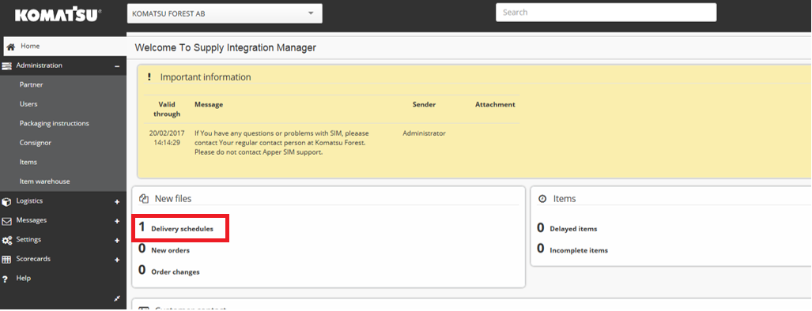

Figure 1: Manage delivery schedules.

Once you have entered a new delivery schedule you will access all information regarding the new schedule. You will also have a weekly overview and order view depending of what tab is selected. You can enter the item details by clicking on the desired item number. Printouts in PDF, Excel, XML etc are also available.

After reviewing the new delivery schedule, you must confirm the delivery plan. When pressing the Confirm button the schedule will disappear from the new delivery schedule list and the current schedule in SIM will be replaced by this new accepted schedule.

Figure 2: Confirming and exporting delivery schedule.

* 1. Dispatching

Working with dispatching in Supply Integration Manager is mandatory to send information to Komatsu Forest AB that a shipment is made but also for an accurate calculation of delivery accuracy (described in section 30). If the supplier fails with this crucial step it can result in incorrect forecasts and demand on the delivery schedule.

* + 1. Creating a dispatch

Komatsu Forest AB recommends that the Auto create tab is pressed when creating a dispatch. This method works with a demand horizon date. The suggested quantities (firm orders) to dispatch are calculated up to this demand horizon. You can manually change the horizon if needed.

The dispatches that are created are separated by the consignee of the shipment,

* 1P = production warehouse, Umea
* 2 = spare parts warehouse, Arlandastad

Please note that you can only have one dispatch in progress for each consignee.

Start with selecting the correct consignee (1P or 2) then press Create button to set you dispatch advice in progress. 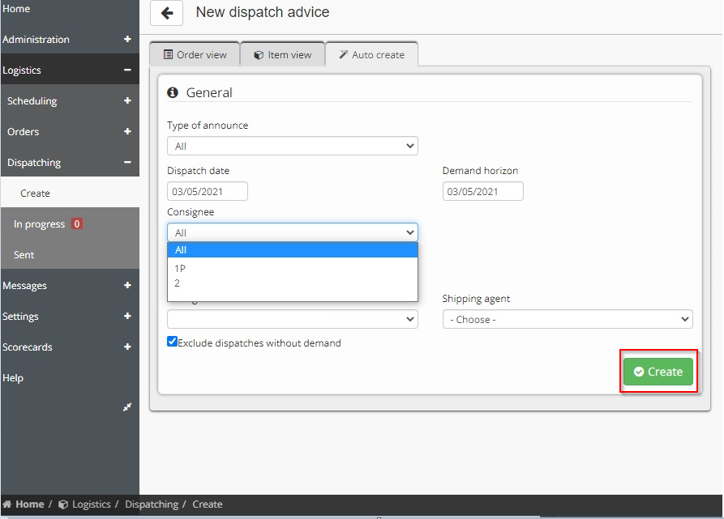

Figure 3: Dispatch.

* 1. Managing a dispatch advice in progress
     1. Dispatch notes and goods labels

Fill in the Consignment note no. You then need to print the dispatch note in PDF (printer icon on the top left) and the goods labels. The printouts are to be used to all shipments to Komatsu Forest AB. The final step is to click the Send dispatch button. All steps described are mandatory and shall be competed with each shipment since it is critical to send correct information to the material planner and to receiving goods department at Komatsu Forest AB.

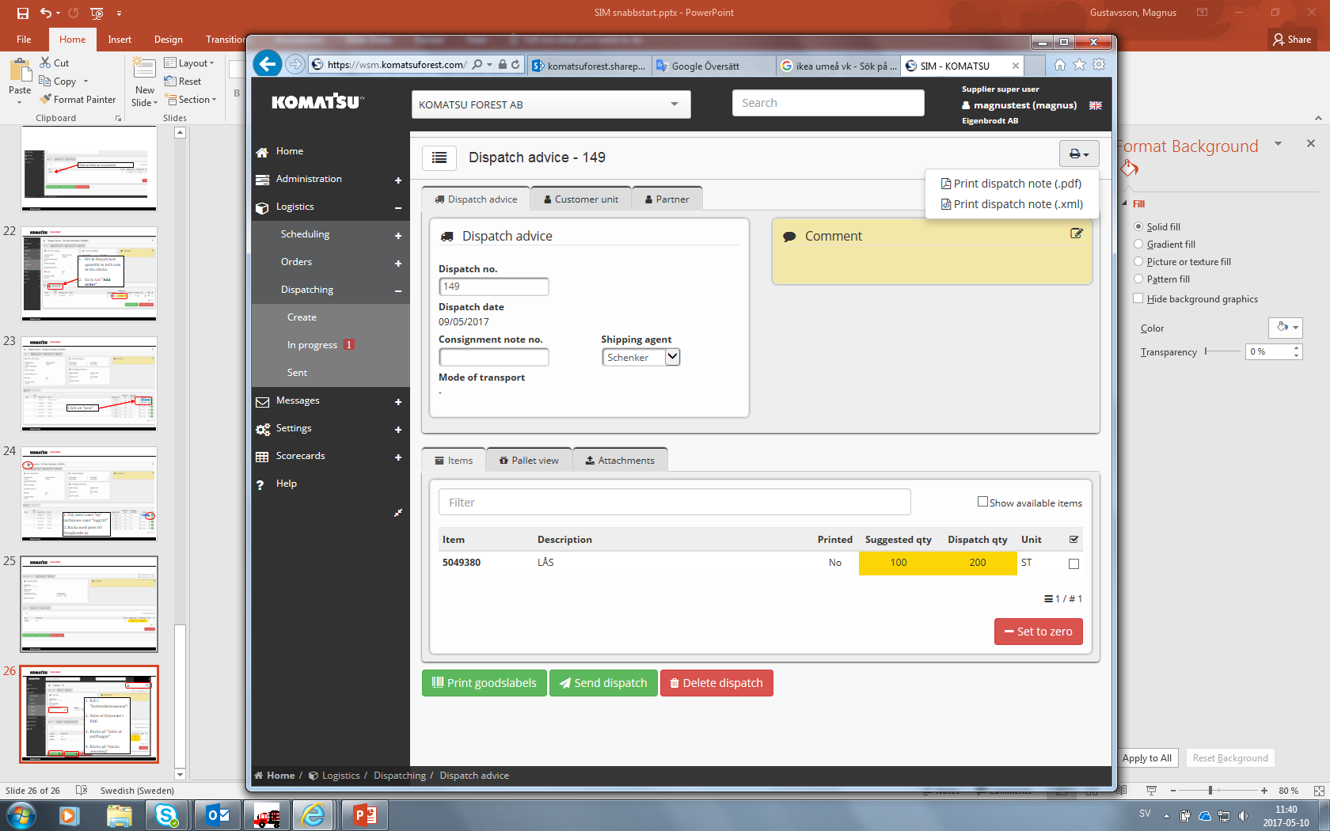

Figure 4: Dispatch note and printing goods labels.

* 1. Delivery schedule definition

The delivery schedule is a documented agreement between Komatsu Forest AB and the supplier. It is an obligation from the supplier to deliver on time. The delivery schedule provides both firm orders as well as the financial commitment from Komatsu Forest AB and forecasts.

The definition and usage of statuses at Komatsu Forest AB:

* Status 1 – Fixed period
* Status 3 – Order coverage section (Purchase of raw material)
* Status 4 – Forecast (planned)

**Status 1 – Fixed period**

The fixed period is the agreed lead time for the Suppliers final production operations and shipment to Komatsu Forest AB. Deviations in respect of quantity and/or delivery date within the fixed period is only allowed if commonly agreed.

The fixed period is to be as short as possible. Komatsu Forest’s general requirement is 2 – 15 working days depending on which product type that is subject for delivery.

**Status 3 – Order coverage section (Purchase of raw material)**

The order coverage period shall reflect the Suppliers lead time for raw material supply and semi-production of parts.

The accumulated quantity within the order coverage period is Komatsu AB’s current delivery requirement of subject part.

The order coverage period is to be as short as possible in order to minimize the economic risk in case of cancellation. Komatsu AB’s requested quantity and/or delivery date may change without prior notice within the order coverage period.

Komatsu Forest AB will, in case of cancellation, take the economic responsibility for raw material, blanks and/or semi-finished parts to the extent that the Supplier cannot cancel their sub-supplier orders or use the products for other purposes (customers and/or products). The Supplier commits to minimize the economic risks by performing good production planning and resource allocation.

In case of request for economic compensation it is the Supplier’s responsibility to verify that the costs have incurred and is relating to the order coverage period of the delivery schedule in effect at the time of Komatsu AB’s cancellation.

**Status 4 – Forecast period (planned)**

The forecast period is to be used by the supplier for long term production planning and resource allocation. However, Komatsu Forest AB does not take any economic responsibility for the part requirements referring to the forecast period.

* 1. Delivery accuracy

Komatsu Forest AB evaluates the supplier´s performance regarding delivery accuracy. This is visualized on the graphic sent to supplier by Komatsu Forest AB.

The supplier´s delivery accuracy is measured according to following method:

The actual date of dispatch on the firm purchase order is compared to the requested date of shipment.

* + 1. Demanded level of delivery accuracy

The supplier shall reach 100% delivery accuracy to Komatsu Forest AB. If the supplier is unable to deliver according to stated demands the supplier will receive a request of analysis due to late deliveries containing following:

1. Identified main problems and analysis of them
2. Corrective actions (short term)
3. Corrective actions (short term)
4. Request of support from Komatsu Forest AB
5. Date for then solutions will be implemented and shipment to Komatsu Forest AB are according to schedule
   1. Packaging

The supplier is responsible for the packaging of goods to assure their proper condition and quality upon delivery to Komatsu Forest AB. FKES 00-300-079 contains general information regarding Komatsu Forest AB’s packaging requirements concerning quality, environmental effects, safety and handling.

The supplier is responsible to ensure that all goods is packaged in such a way to that handling-safety is maintained throughout the whole supply chain. For deliveries containing electronic items, the supplier must meet the requirements stated in the standard FKES 00-100-035. The type of packaging the supplier shall use, shall be established and agreed between the supplier and Komatsu Forest AB before first delivery.

The supplier shall take environmental concerns into account when planning packaging e.g. excessive packaging material which serves no actual purpose is considered as waste.

* + 1. Documents

Goods arriving to Komatsu Forest AB shall always have consignment and delivery notes enclosed. Shipments including pallets and/or special packaging must also include a delivery note for packaging. Template for delivery note can be found in standard FKES 00-300-079

* + 1. Approved packaging

Komatsu Forest AB approves goods when delivered as:

* Parcel
* Euro-pallet
* Special packaged goods

EUR-pallets shall always have collar(s) and lid. Maximum number of collars and maximum weight approved as standard packaging for EUR-pallets and parcel can be found in FKES 00-300-079. Half sized pallets (800x600 mm) are not allowed by Komatsu Forest AB.

Special packaged goods are defined as following:

* Goods with dimensions exceeding the dimensions of a EUR-pallet
* EUR-pallet with more than 4 collars
* EUR-pallet without collar(s) and lid
* Goods that are not packed on a EUR-pallet and therefore require special packaging

Shipping of special packaged goods is not allowed without an agreement with Komatsu Forest AB. More detailed information about special packaging is stated in standard FKES 00-300-125

* + 1. Approved pallets

The type of pallet approved by Komatsu Forest AB is EUR-pallet class A or B. The dimension of a EUR-pallet is 1200x800x144 mm (length, width, height). Detailed information about classification is stated in standard FKES 00-300-079.

Komatsu Forest AB does not accept pallets failing to fulfil the standard of a EUR-pallet class A or B. The pallet shall fulfil the specifications set by the European Pallet Association (EPAL) regarding dimensions, markings, type of materials etc.

The supplier is responsible that the pallet(s) used, comply with the latest revision of ISPM15 concerning international import and export directives. ISPM15 includes for example that wooden pallets shall be heat treated or fumigated to prevent the spread of plant diseases and pests.

* + 1. Collars, Lid, Inner deck board
* The height of each collars is the standard size of 195mm
* The lid shall consist of a 5,5mm thick wood fibre board
* The inner deck board consist of a 3mm thick masonite sheet

Detailed information about collars, lid, inner deck board is stated in standard FKES 00-300-125.

* + 1. Supplier packaging rates and packaging invoicing

Komatsu Forest AB pays the cost for standard packaging according to the pricelist stated in standard FKES 00-300-079. The price for special packaging shall be regulated in a separate agreement between supplier and Komatsu Forest AB. Invoicing of standard packaging shall be distinguished from the freight invoice and separately summarized on a monthly basis.

* 1. Labelling instructions

All goods delivered to Komatsu Forest AB shall be labelled with a goods label in accordance with the ODETTE transport label (Organization for Data Exchange by Tele Transmission in Europe). The practice of The Odette Transport Label is intended to be used on all transport packages containing goods to Komatsu Forest AB. The main purpose of using a goods label is to ensure an even flow of material tied to the production throughout the entire supply chain, as well as the identification and traceability of transport units. Goods shall never arrive at Komatsu Forest AB unlabelled.

* + 1. Label

The format of the goods label is A5 (210x148 mm). However, if needed, the goods label may be printed on a larger paper size e.g. A4 (210x297mm). Paper used for the label must be white with black printing.

For printing of goods labels 100g white paper is to be used. The label must be durable enough to ensure readability at its destination, i.e. being weather resistant and withstand handling during transport.

* + 1. Font face

The following character set is to be used:

* Font: **Helvetica bold**
* Character Set: ISO 3098-1
  + 1. Titles and identifiers codes

In the upper left corner of each data area, the data area titles shall be printed. This information is to be printed in English or Swedish. Font size to be used is 1.5 mm. Data Identifiers shall be included as a part of the data area title. Detailed information is stated in standard FKES 00-300-080.

* + 1. Label data area content

Table 2.

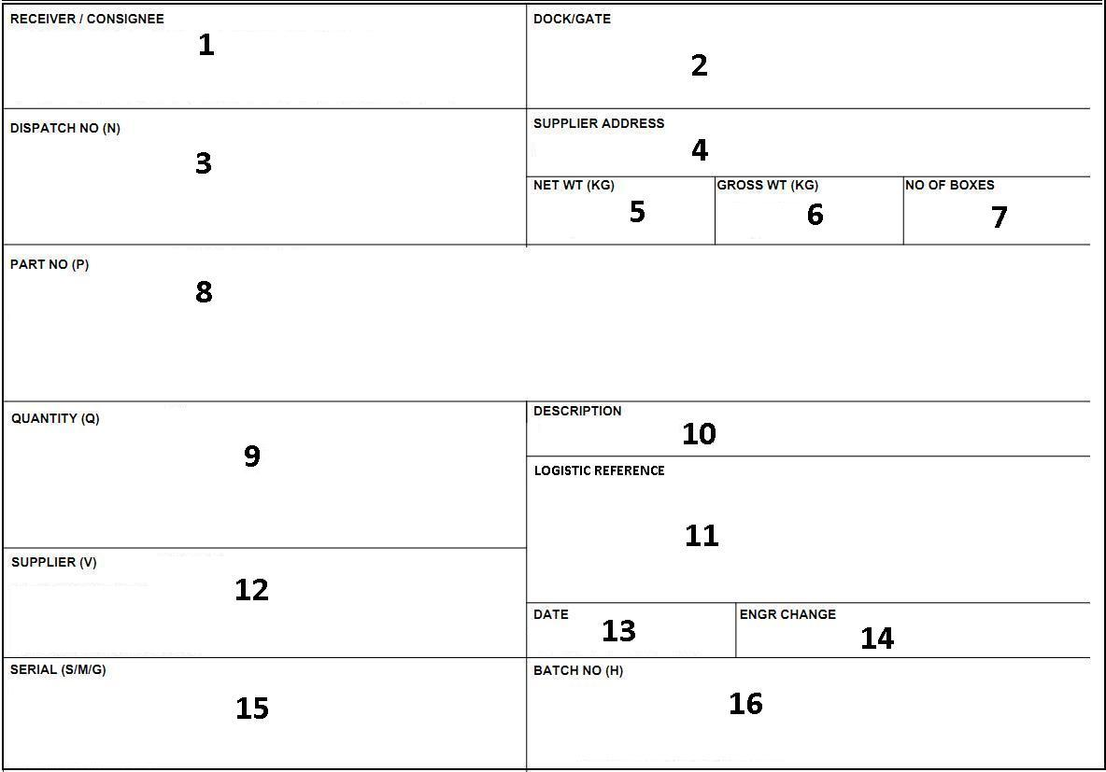

* + 1. Data area content specifications

Table 1. The usage of data identifiers and which data areas are “Required”, “Optional/Dependent” or “Not used”. Detailed information about specifications is stated in Standard FKES 00-300-800.

**User attributes: User attributes:**

R = Required N = Advice note number

D = Dependent P = Part number

N = Not used Q = Quantity

V = Supplier ID

H = Purchase Number

Table 3.

|  |  |  |  |
| --- | --- | --- | --- |
| Number | Field name / Description | User attributes | Data identifiers |
| **1** | **Receiver** Komatsu Forest AB unloading location. | **R** |  |
| **2** | **Dock/Gate** Komatsu Forest AB final delivery point. | **N** |  |
| **3** | **Dispatch No.** Supplier dispatch number. | **R** | **N** |
| **4** | **Supplier Address** Supplier name and address, country of origin. | **R** |  |
| **5** | **Net Weight** Material weight within transport unit. | **N** |  |
| **6** | **Gross Weight** Total transport unit weight. | **N** |  |
| **7** | **No. of Boxes** Number of packages within one transport unit. | **N** |  |
| **8** | **Part Number** Komatsu Forest AB part number. | **R** | **P** |
| **9** | **Quantity** Package- or transport unit quantity. | **R** | **Q** |
| **10** | **Description** Komatsu Forest AB part description. | **R** |  |
| **11** | **Logistic Reference** | **N** |  |
| **12** | **Supplier ID** Supplier number/ID. | **D** | **V** |
| **13** | **Date** Material dispatch date. | **D** |  |
| **14** | **Engineering Change** Komatsu Forest AB engineering change note. | **D** |  |
| **15** | **Serial Number** Supplier package or transport unit identification number. | **N** |  |
| **16** | **Batch NO.** Komatsu Forest AB purchase order number. | **R** | **H** |

* + 1. Examples of goods label layout

Goods label for a **non-mixed transport unit**. Used on a transport unit containing one (1) part number.

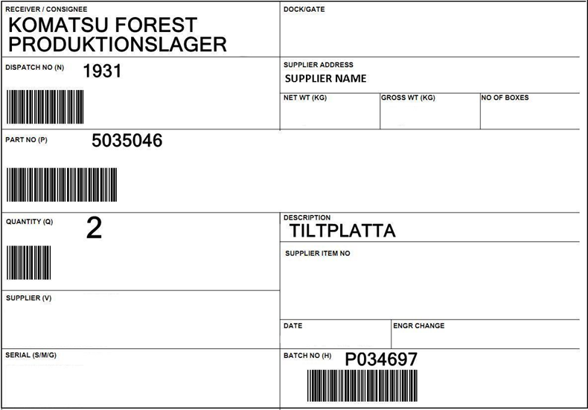

Figure 5: Goods label for a non-mixed transport unit.

If the supplier fails to provide a label shown below (figure 8.3), a similar label including the term “MIXED”, can be printed on a larger paper size e.g. A4 and subsequently be firmly attached to the transport unit. Detailed information about mixed pallets is stated in Standard FKES 00-300-080 and 00-300-079.

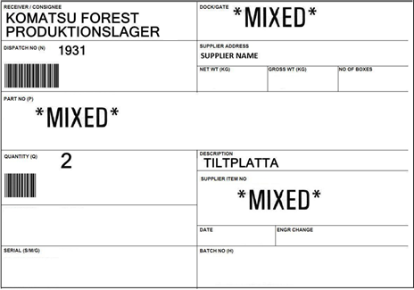

Figure 6: Goods label for a mixed transport unit.

* + 1. Barcode

All barcodes must be of type 3-of-9 (code 39). The format for each bar code-element is: Start character, Identifier (Data Identifier), Data characters and Stop character.

All bar-coded areas are printed left justified. Detailed information about barcodes is stated in standard FKES 00-300-080.

* + 1. Affixing and placement

On wooden packing material shall the goods label be horizontally secured with staples. If self- adhesive goods labels are used, the label may in addition be secured with staples to ensure its fixation. The label must be secured enough to ensure fixation at its final destination, i.e. being weather and transport resistant.

Correct placement of the goods label.

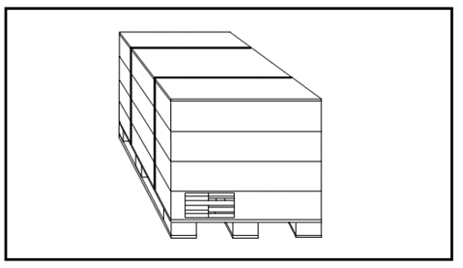

Goods label

Figure 7: Goods label placement.

* 1. Transport instruction

Agreed trade terms shall be interpreted in accordance with INCOTERMS 2010. If no trade terms are specifically agreed, the delivery term shall be FCA supplier’s factory. The following instructions are always to be followed in order to maintain low transport costs;

* Goods packed on pallets must be stackable and booked for transport accordingly
* Bulk goods must be booked as load meters
* Strictly one booking to be sent to the forwarder per day
* Transport is to be booked the day before pick-up according to agreement with Komatsu Forest AB (see Standard FKES 00-300-081 for domestic suppliers. Standard FKES 00-300-082 for foreign suppliers)

Throughout transport instruction section, please see Standard FKES 00-300-081 for domestic suppliers and Standard FKES 00-300-082 for foreign suppliers.

Responsible material planner at Komatsu Forest AB will provide supplier with information regarding use of carrier etc.

* + 1. Way-bill/shipments form

Details states in Standard FKES 00-300-081/082.

* + 1. Booking of transport to Umea and Arlandastad

All bookings for foreign suppliers for both Umea and Arlandastad shall be made in accordance to Standard FKES 00-300-81/082. Information about booking first delivery can be found in stated standard FKES.

* + 1. Freight forwarder

All deliveries shall be booked with the freight forwarder appointed by Komatsu Forest AB. As soon as the “first delivery” information has been provided to Komatsu Forest AB, the material planner will contact the freight forwarder who will send the supplier a ”Routing order” with the contact information needed for transport booking.

* + 1. Express transport due to late delivery

In the event of late a delivery this is to be communicated without delay to the material planner at Komatsu Forest AB. If the delay can be expected to cause interruption or line stops in the production at Komatsu Forest AB, the delivery of the specific product must be organized and paid for by the supplier. The supplier and the material planner at Komatsu Forest AB must make the assessment and meet an agreement regarding which part number(s), quantity, way of transport and time of arrival. Details are stated in Standard FKES 00-300-081/082.

* 1. Invoicing

Invoices shall be sent to [invoice@komatsuforest.com](mailto:invoice@komatsuforest.com) in PDF format. Following information are mandatory to be stated in the invoice:

* Komatsu Forest purchase order number
* Item number
* Quantity
* Delivery note number

1. Cost

This chapter describes the Komatsu Forest AB sourcing process. This process follows SLQDC – Policy, (as explained earlier in this handbook), this is the foundation of the processes and routines within the strategic sourcing department. SLQDC covers areas within Safety, Legal, Quality, Delivery and Cost.

New and existing suppliers to Komatsu Forest AB are asked to actively partake in this process. This is to verify that Komatsu Forest AB requirements are met.

* 1. Komatsu Forest AB purchasing general conditions

Our Purchasing General Conditions states the basic commercial conditions that a supplier is required to fulfill in the business with Komatsu Forest AB. These conditions apply for products and services in order to follow the entire life cycle that they are supplied. These Purchasing General Conditions are applicable to individual orders as well as ongoing serial delivery. Formal Supply Agreements between Komatsu Forest AB and suppliers has priority over the Purchasing General Conditions.

* 1. Confidentiality agreement

All business and discussions are confidential. To protect both parties, a Komatsu Forest AB standard confidentiality agreement must be signed by both parties. Upon a signed agreement, the supplier is approved to take part in the Komatsu Forest AB sourcing process and may be provided with a Request for Quotation or Request for Information.

A new supplier will have to agree to follow the specifications and requirements set forth by our processes. These processes include; Safety, CoC, General Purchasing Terms, Drawings, Technical Specifications (regarding both dimensions, cleanliness, and or other treatments), and adhere to FKES standards.

* 1. Request for information, request for quotation

Komatsu Forest AB may at a given time request an item or product to be supplied, a Request for Quotation or Request for Information together with drawings and/or other specifications is sent out to concerned and approved suppliers. The Request for Quotation specifies what basic information that is requested such as prices and lead-times on prototypes and initial samples and first serial production order. The quotation should include all relevant information that affects the part, such as; country of origin, tariff code, price and lead time for special tooling or fixtures. The Request for Quotation will also state when the reply date is due. Depending on what kind of item or product that is quotation, Komatsu Forest AB may ask the supplier to supply a Cost Break Down.

* 1. Cost break down

Komatsu work with detailed Cost Break Down. The format of this depends on the commodity. Suppliers are expected to present and specify costs and manufacturing operations of which the quotation is based on. It includes cost of raw material and/or purchased parts, machine costs and labour rates, overheads and margins.

* 1. Evaluation of quotation

Komatsu Forest AB will evaluate the quotation and contact the supplier to complete or explain any information that is unclear. Depending on which item or product that is concerned, a supplier could be asked to present a more detailed presentation of the case and its manufacturing process. If the supplier’s quotation and case is competitive, Komatsu Forest AB could request to perform a Supplier Audit.

* 1. Supplier evaluation

Depending on what kind of item or product that is open for quotation, Komatsu Forest AB could also decide to make a supplier visit and perform a Pre-audit at the supplier’s facility.

* 1. Audit

Komatsu Forest AB regularly perform audits and pre-audits in order to validate potential suppliers from different aspects. These are performed in order to confirm that SLQDC is followed, that all risks in a production process is minimized and that our policies are followed. If any issues are found an action time plan is made to correct any deviations.

Areas that are covered in this process are:

* Safety
* General information
* Ownership
* Commercial
* Financial information and performance
* Manufacturing facilities
* Quality
* Delivery accuracy
* Environment
  1. Supplier audit (suppliers’ location)

A Supplier Audit is performed at the supplier’s facility. The on-site audit may focus on different processes and areas depending on the supplier and product to be sourced. The supplier is expected to answer detailed questions and show documentation upon request. An audit report is then made and shared with the supplier. A supplier visit will consist of at least a strategic purchaser and an SQA from the quality department. Other representatives may attend depending on the commodity, or technical requirements/specification.

* 1. Supplier selection

The supplier is informed about the outcome, after all information is gathered and possible audits are performed. If a new supplier is chosen, Komatsu Forest AB General Purchasing Terms are applied, and the parties’ obligations are governed through an official contract.

* 1. Supplier implementation

When a supplier has been chosen and commercial agreements are done, a detailed project plan needs to be presented by the supplier with distinct milestones and dates based on input from Komatsu Forest AB. This includes information such as product review, tooling and/or fixture lead-times, prototype lead times, initial samples and records, first delivery of serial production etc.

Komatsu Forest AB will introduce people from the different departments (logistics, material planning) to the supplier’s organization.

|  |  |  |  |
| --- | --- | --- | --- |
| Version | Utfärdad datum /  Date of issue | Utfärdad av/  Issued by | Beskrivning/  Description |
| 1.0 | 2019-11-26 | AnLi | Nytt dokument. / New document. |
| 2.0 | 2021-06-01 | KrJo | Ny framsida, uppdaterade kvalitetskrav / New front page, updated quality requirements |
| 3.0 | 2025-01-08 | DaSj | Change of document owner and reviewer (metadata). No change to content. |